BACK END – ENQUIRIES MANAGEMENT

Currently we have the following briefed to development as per wireframes:
All lead form data is saved to Kentico Bizform, and sent to the appropriate destination expert.
- Tour code
- Tour name
- The data from the RHS form - Departure date, class, departure city, quoted prices as shown on screen
Depending on the destination of the tour, a notification will need to be sent to a specified email for the relevant destination team.
Generic enquiries will be attributed to a generic info@entiretravel.com.au email.
Enquiry management tool expectations:
- The enquiry management tool will be utilised as a simple CRM
- Requires ability to manually add entries and alter fields, eg:
  - Add an entry if someone enquires over the phone
  - Add/amend email on an already existing enquiry
- Enquiries need to be viewed in two ways:
  - Top level ‘at a glance’ (example in appendix 1.1)
  - Individual-enquiry level, showing full detail of the enquiry (example in appendix 1.2)
- An export of enquiries should provide a CSV with all data captured in an enquiry (plus any additional notes made by the consultant), not just the top-level data
- Two user/permission types:
  - Manager
    - Ability to assign, update and delete enquiry
  - Consultant
    - Able to assign, update enquiry
    - No permission to delete enquiry

Back-end enquiry views, and what each role should see:

Top level | Individual-entry level | Manager | Consultant
Name |  | x | x
Email address |  | x | x
Phone # |  | x | x
Brand |  | x | x
Product/page name from which the enquiry is coming |  | x | x
Time/Date of enquiry |  | x | x
Status |  | x | x
Consultant |  | x | x
UTM source |  | x
UTM medium |  | x
UTM content |  | x
UTM campaign |  | x
 | Page URL | x | x
 | All other form fields (departure city, free-form enquiry message etc) | x | x
 | Comments manually added by consultant | x | x
 | Booking # | x | x

Customer enquiry workflow

The following is an outline of the process for incoming enquiry, and how they are handled:

- Auto-email to customer (Thank you for your enquiry…)
  - This is to match the ‘look and feel’ of the EDM template
- Enquiry goes into Kentico back end, default status set as ‘new’
- Sales manager assigns the enquiry to a specific consultant (picking the consultant from a drop-down)
- Consultant receives email notification of the awaiting enquiry in Kentico
- Consultant marks the enquiry as ‘WIP’ and begins handling the enquiry off-platform
- Consultant marks the enquiry as confirmed or cancelled
- Confirmed status triggers mandatory new fields such as “booking reference” / Departure dates / Return Dates (allowing further touch points with the consumers via Kentico Marketing automation)
  - Consultant will be unable to save an enquiry as “confirmed” until the triggered fields are completed

A detailed flowchart follows on the next page.

enquiry receipt confirmation sent to visitor’s email address
NO
YES
Consultant marks enquiry as cancelled
Consultant marks enquiry as confirmed
Did customer book
Enquiry handled off-platform
Consultant marks enquiry as WIP
END
Follow-up automation processes upon return from trip
New fields are triggered, allowing consultant to add notes, booking reference, etc) – MANDATORY FIELDS
Assigned consultant receives notification by email of awaiting enquiry
Sales Manager assigns the enquiry to a specific consultant (via drop-down)
Kentico back-end collects enquiry in table/database
Visitor fills out enquiry form
START

APPENDIX

1.1 – Top-level enquiry view

At a glance, we can see helpful information such as brand, package being enquired about, status of the enquiry, consultant it has been assigned to, source of the enquiry etc

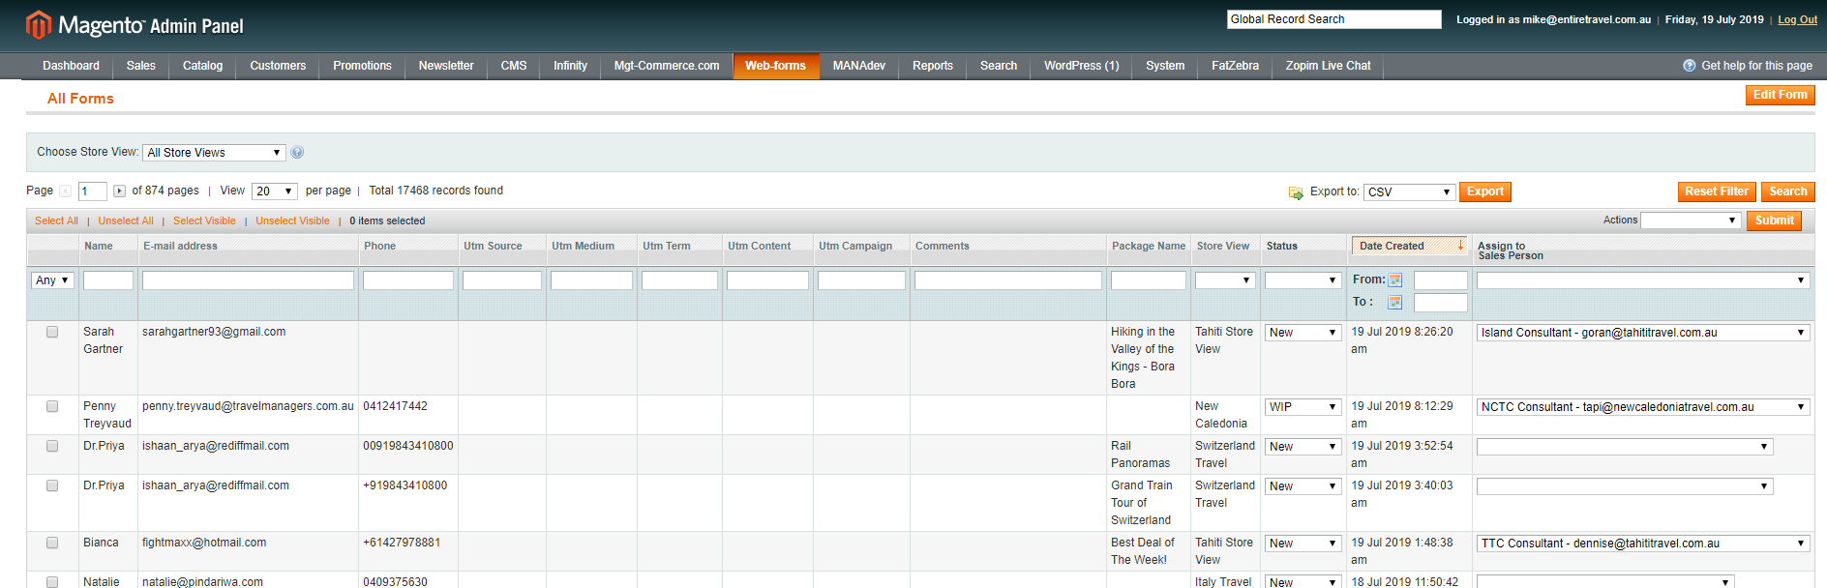

1.2 – Individual-entry level view

From the top-level view, selecting a specific enquiry will present a view of all the data associated with a specific enquiry. This includes all the data from the top-level view, along with the enquiry message, and any additional form fields that may have been populated (preferred contact method, departure city, duration, etc)
